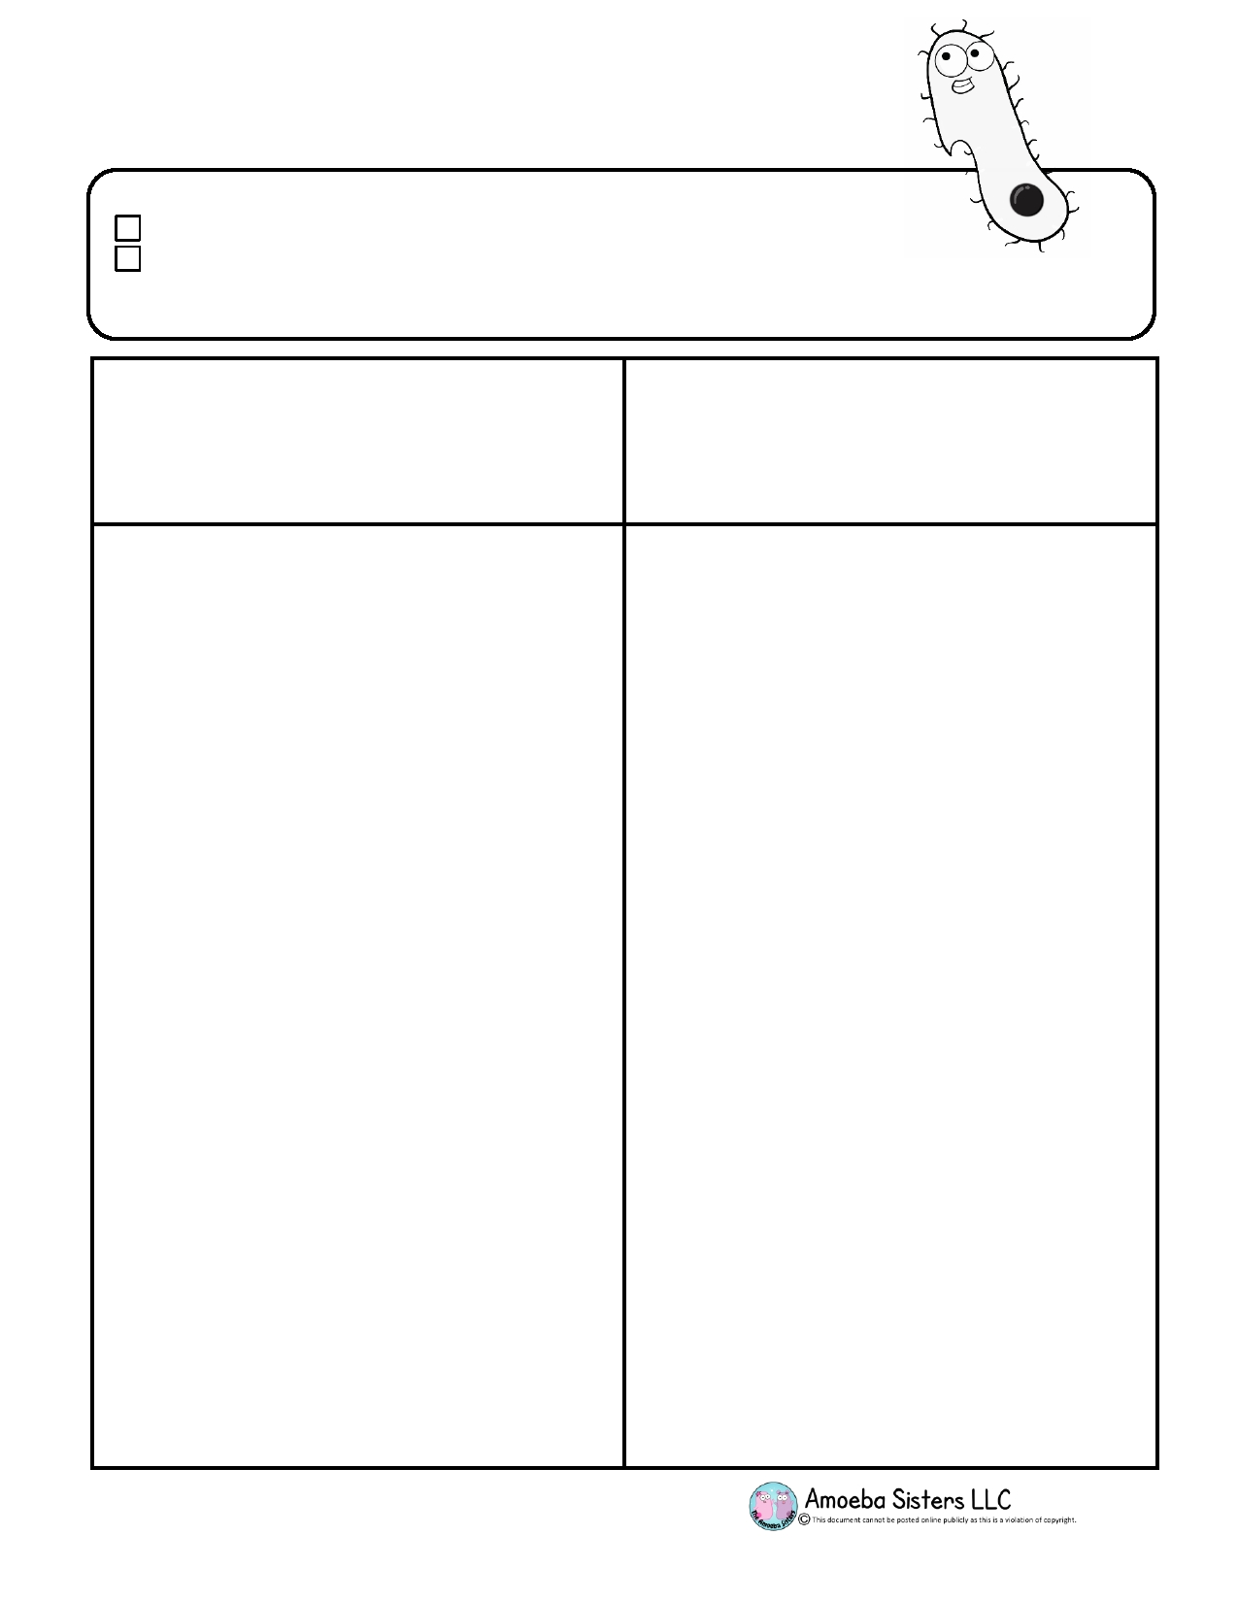Name: _________________________________________________________
Amoeba Sisters: Annotated Video Script Template
Meiosis

Rewatch the Amoeba Sisters Meiosis Youtube video and answer the questions below.

_

Video Script (informal)
Note: The informal script below may have some slight improvements
from the direct transcript on YouTube. Improvements are made to
help define sentences and to remove excessive filler words that can occur when speaking. By making these improvements, this script is
easier to annotate. However, the transcript on YouTube can be viewed in real time by clicking "CC" on the video for captioning.

- Write 3 things you already knew about Meiosis
- Write 3 things you learned about Meiosis
- Highlight 10 scientific vocabulary words. You will find the highlight tool under the home screen. The icon looks like the little highlighter pen pictured below.
- Choose 3 of the 10 vocabulary words that you highlighted that were new words to you and define them.

Scroll down to page 2 and begin typing your answers!
"Have you ever wondered how two siblings can have the
same mom and dad and still look so different? Well, today
we're going to talk about a process that makes that possible! We are going to talk about a process called
meiosis! This is not to be confused with mitosis, which sounds unfortunately similar.

Mitosis makes identical body cells like your skin cells and
stomach cells. Recall from our mitosis clip that since it
makes identical body cells, mitosis is important for growth,
repair of damage, and to replace worn-out cells. But not meiosis. Meiosis is a process that contributes to genetic
variety. Meiosis also doesn't make body cells. Meiosis
makes sperm and egg cells, otherwise known as gametes, the fancier word.

You might recall that humans have 46 chromosomes.
That's how many chromosomes most body cells in your
body have. But there are some human cells that don't have
46 chromosomes! Human sperm cells and egg cells have 23 chromosomes. Why the number difference? Well if a
sperm cell has 23 chromosomes and an egg cell has 23 chromosomes, this makes 46 chromosomes when they come together. This will allow a newly formed fertilized
egg to develop into a human! Meiosis is what
we call a reduction division, because you have a starting cell that has 46 chromosomes and your ending cells (the sperm and egg cells) have only 23 chromosomes.

Page 1 of 4
Questions and Sketches
We learn from connecting what we already know to new concepts. Asking questions and defining new vocabulary help us to expand our knowledge of a concept. Follow the guidelines below to make these connections with meiosis.

Amoeba Sisters: Annotated Video Script Template
Meiosis

Type your answers below:
Before we can get into the stages of meiosis to make gametes, we have to remember what happens before
meiosis can even start. Actually, this also happens before
mitosis. It's the stage known as interphase. If you
remember interphase, it's when the cell is growing, it's replicating its DNA, and it's carrying out cell processes.
Interphase happens once before division starts, just like in mitosis.

Therefore, before meiosis is even going to start, the
starting [human] cell has 46 chromosomes, and you have
to duplicate those chromosomes in interphase before
meiosis starts. This means you are duplicating your DNA, since chromosomes are made of DNA and protein. Ready for the tricky part? Since we tend to count chromosomes
by the number of centromeres present, after the 46 chromosomes duplicate, we will still say there are 46
chromosomes. This is because the sister chromatids are
still attached, and we are counting by centromeres. So 46 chromosomes here, they replicate in interphase, and you still have 46 chromosomes in this picture. However, you
went from 46 to 92 chromatids. Little tricky there!

Okay, so now the interphase checklist is done! We can
move into meiosis! You might remember the mitosis
stages PMAT with the P representing prophase, the M representing metaphase, the A representing anaphase,
and the T representing telophase. The good news is that in
meiosis, you still use those terms. However,
since meiosis is a reduction division, you're going from 46 chromosomes to 23. This means you actually divide twice.
You do all the PMAT stages twice. Therefore, you put
numbers after the phases to indicate whether you're in the first division or the second division.

So let's dive right in! Starting with the very first step,
prophase I. One thing I like to remember about prophase
is pro can mean 'before' and so this can help you
remember that it comes before all the other stages start.
This is where the chromosomes are going to condense and
thicken. The chromosomes are going to line up with their homologous pairs.

Page 2 of 4

Amoeba Sisters: Annotated Video Script Template
Meiosis

Type your answers below:
The word homologous means that the chromosomes are approximately the same size, and they contain the same
types of genes in the same locations. They're going to match up. It is during this prophase I that this amazing
process occurs called crossing over! Crossing over is when the chromosomes, lined up in homologous pairs, have this
way that they can transfer their genetic information and
exchange it between each other! It's kind of like these
chromosomes flop over each other and do a little genetic
information exchange here! It makes for what we call
recombinant chromosomes which can eventually
contribute to the variety that we were mentioning at the beginning.

Now we move into metaphase I. In metaphase I, think of
the M standing for middle. The chromosomes are now
going to be in the middle of the cell. It's a little bit different
though from mitosis, because these chromosomes are
going to be in pairs in the middle of the cell so it's
not a single-file line. The chromosomes are in pairs in the middle.

Now during anaphase, I like to think of "a" for away,
because the chromosomes are going to be pulled away by the spindle fibers.

Then we end with telophase I where you have two newly
formed nuclei and it becomes obvious that you're going to
end meiosis one with two new cells. Cytokinesis follows
with splitting the cytoplasm, but we're
not done yet!

Continuing into meiosis II! The very first step in meiosis II is prophase II. It's not going to be nearly as eventful as it was
in prophase I though, because there are not homologous
pairs of chromosomes. There is no crossing over. That
doesn't happen again. In prophase II, you have the
chromosomes and the spindles starting to form like they
did in prophase I. However, prophase II is just not as
eventful with it not having that process of crossing over.

Page 3 of 4

Amoeba Sisters: Annotated Video Script Template
Meiosis

In metaphase II, I think M for middle again. The
chromosomes are going to line up in the middle. This time
though, they are in a single-file line. They are not in pairs
like they were in metaphase 1!

Next is anaphase II. I remember the "a" for away, but this time it's the chromatids that are going to be pulled away by the spindle fibers.

In telophase II, you can see the nuclei reforming. You can
also see that the two cells have divided. There are going to be four cells forming. Cytokinesis will follow to completely split the cytoplasm.

Now keep in mind that meiosis in males produces sperm
cells. In females, meiosis produces egg cells. Due to
independent assortment and crossing over, you're going to
have variety. For example, [in males] the four sperm cells
that are produced each time are all different from each
other, and they're also different from the starting cell. The starting cell had 46 chromosomes and the ending cells only
have 23 so they are not identical to the original and they
are not identical to each other. This is going to lead to variety, which is one reason why two siblings with the
same parents can look different from each other! They still developed from a unique egg and a unique sperm cell that
came together!

One last thing to think about. Sometimes the
chromosomes don't separate correctly. This is called
nondisjunction, and it can result in the cell receiving too
many or too few chromosomes in the separation. This
contributes to some genetic disorders which is something scientists continue to study. Well, that's it for the Amoeba
Sisters, and we remind you to stay curious!"

Check your work!
Did you:
• Mark information that you already know? Y / N
• Mark key information that is new? Y / N
• Did you write down your questions on the right margin? Y / N
• Underline vocabulary terms? Y / N

Page 4 of 4

