Animal Cell and Organelles
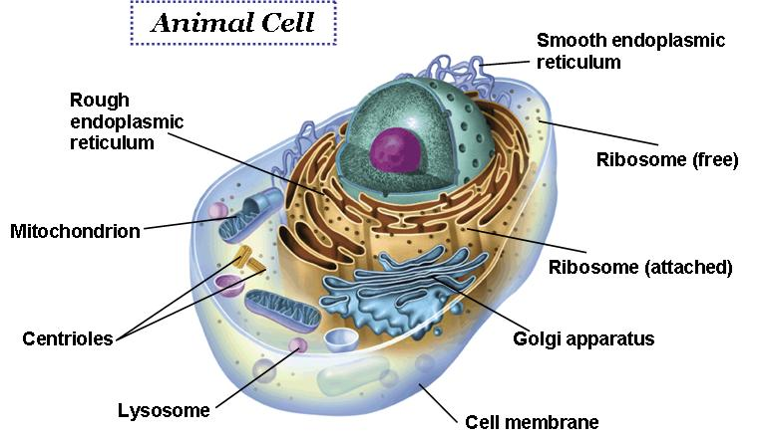

Cell Membrane – Determines what goes in sand out of the cell. Protects and supports the cell
Cytoplasm – supports and protects cell’s organelles. Contains some nutrients for the cell
Nuclear Membrane- Decides what goes into and out of the nucleus – DNA is too large but RNA is small enough to leave
Nucleus – (Contains Chromatin and nucleolus): Directs cell activities. Chromatin- genetic material – DNA (Chromosomes) which contain instructions for traits. Nucleolus- makes ribosomes
Ribosomes- makes proteins
Vacuole- help maintain shape storage, digestion and waste removal
Lytic Vacuole- Functions similarly to a lysosome; digests excess or worn out organelles, food particles, and engulfed viruses or bacteria.
Smooth Endoplasmic Reticulum- Transports proteins and breaks down toxins in the cell. DOES NOT contain ribosomes
Rough Endoplasmic Reticulum- Transports proteins and breaks down toxins in the cell. Covered in ribosomes which make proteins that are transported.
Mitochondria – “Powerhouse” of the cell. Produces energy from sugar through chemical reactions (Cellular respiration)
Golgi Body/ Apparatus- Processes and packages proteins and lipids. Moves material within the cell and out of the cell in small sacs called vesicles.

