«First_Name»«Last_Name»
To access your 365 account, go http://office.com
and enter the username and password below.

Username: «Email»
Password: «Password»

When you first log into your 365 it will load into the dashboard which contains all of your available apps.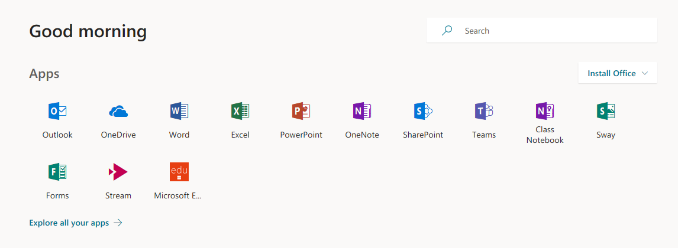
From here you can access all of the Microsoft suite, you can also download the full versions for FREE!!!!
You are allowed to put these on up to 5 devices, including PC, Apple, Laptop, Tablets and Phones.
To access or store files (including pictures) go to your 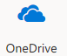. The OneDrive is your cloud storage. You can save files here, you can create new folders, and open all your other files.
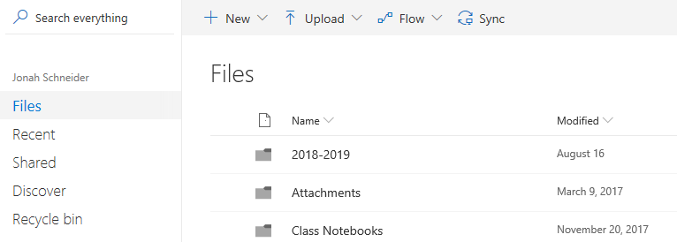
You can save files in your OneDrive by either
- Click on Upload, select files and fins your files in the box that pops up
- Drag your files from your computer’s file manager and drop them into your one drive

