Work to be turned in May 4-8
This is a quick chart for ELA, Math, Science, and Social Studies Assignments
Need to be turned in and will be recorded in Power School
**Remote Plans are on the next page.

Turned In
Reading: Moka the Little Golden Dog with questions
on Read Works

(assigned on Tuesday)

Reading: Questions for Story on ELA TEAMS
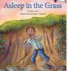
Asleep in the Grass
(assigned on Thursday)

Spelling: 4 activities spelling city
(assigned on Tuesday and Thursday)

English: Complete the possessive pronouns activity on IXL
(assigned on Tuesday)

Math – Mrs. Poggensee Happy Numbers
Monday 20 minutes and Wednesday 20 minutes
Math - Mrs.Skrobanski
Check Mrs. Skrobanski’s Homeroom page and Math page in Teams
(assigned on Monday and Wednesday)
Science For all 4th grade: assignment modified by Mrs. Poggensee
How Rocks Form (assigned on Monday)
Reading and Questions to complete are on Teams

Social Studies For all 4th grade: assignment modified by Mrs. Poggensee
Chapter 10 Review (assigned on Wednesday)
Book Link and Questions to complete are on Teams

Mrs. Poggensee Remote Learning 4th Grade Week of May 4-8
The math assignments listed are for the students who have math with Mrs. Poggensee.
4th grade; Go on Teams for Reading/English-ELA (Mrs. Poggensee),
Science, and Social Studies (Mrs. Skrobanski)
If highlighted in yellow, these assignments need to be turned in.
Time  Subject | Math  Science  Monday |  | ELA  Spelling/Reading/ English  Tuesday |  | Math  Social Studies  Wednesday | ELA  Spelling/Reading  Thursday | Flexible  Friday
8:00  8:30 | Wake up, Breakfast, Get Ready for the Day
8:30  9:00 | Freckle/IXL  student.freckle.com  or  IXL.com  your username and password were emailed to your parents | Spelling  spellingcity.com  your username and password were emailed to your parents  You are only required to complete 4 activities this week.. |  | Freckle/IXL  student.freckle.com  or  IXL.com  your username and password were emailed to your parents |  | Spelling  spellingcity.com  your username and password were emailed to your parents  You are only required to complete 4 activities this week.. |  | Perfect time to make sure your work is turned in.
9:00  10:00 | Math  https://happynumbers.com/  Work 20 minutes or more. Do not guess, use paper as needed.  - pick I’m a student  - 4th grade code  825 913  - Click on Your name and begin  If Mrs. Skrobanski is your math teacher go to her page on TEAMS | ELA/Reading  Readworks.org  class code:  MBB3NE  Find your name  Password: 1234  Moka the Little Golden Dog  - listen  - read  - answer the comprehension questions  If you want, you can start reading Asleep in the Grass  Listed under Thursday’s Reading |  | Math  https://happynumbers.com/  Work 20 minutes or more. Do not guess, use paper as needed.  - pick I’m a student  - 4th grade code  825 913  - Click on Your name and begin  If Mrs. Skrobanski is your math teacher go to her page on TEAMS |  | ELA/Reading  Think Central  Asleep in the Grass  On think central  - Listen or read the story  - complete the comprehension worksheet on ELA TEAM  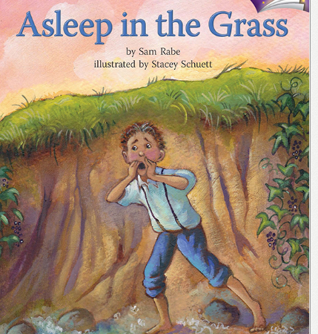 |  | Perfect time to make sure your work is turned in.  Practice on a site of choice.  Check out sites listed on your web  chart  If you need another one I will email it.
10:0010:30 | P.E. / Movement Break  Check Mr. Jacobi  Ms. Shea  Teacher’s Page | P.E. / Movement Break  Check Mr. Jacobi  Ms. Shea  Teacher’s Page |  | P.E. / Movement Break  Check Mr. Jacobi  Ms. Shea  Teacher’s Page |  | P.E. / Movement Break  Check Mr. Jacob  Ms. Shea  Teacher’s Page
10:3011:00 | Silent Reading  Read a book you have at home  Or  Raz Kids  kidsa-z.com  teacher: jpoggensee  Click on Your name; password your first name | Tech  Log on to Mr. Schneider’s page for his assignment |  | Silent Reading  Read a book you have at home  Or  Raz Kids  kidsa-z.com  teacher: jpoggensee  Click on Your name; password your first name |  | Silent Reading  Read a book you have at home  Or  Raz Kids  kidsa-z.com  teacher: jpoggensee  Click on Your name; password your first name |  | Perfect time to make sure your work is turned in.
11:0011:45 | Lunch | Lunch |  | Lunch |  | Lunch |  | Lunch
11:4512:30 | How Rocks Form  Reading & Questions  On Science Team  There is a power point that reads the article to you  *you need to turn in the worksheet | English  Possessive Pronouns  Watch video on you-tube, click on link above: possessive pronouns  Complete 2 possessive pronoun activities on IXL –links are below but you have to sign in  Identify possessive pronouns  Use possessive pronouns |  | Social Studies  Chapter 10 Lesson 3-Illinois  *you need to turn in the worksheet  Link to social studies book: |  | Make sure IXL English is completed from Tuesday  Make sure Science is completed from Monday  Make sure Social Studies is completed from Wednesday |  | Practice on a site of choice.  Check out sites listed on your web  chart  If you need another one I will email it.
12:301:30 | Art  Visit  Ms. Hole’s Teacher Page  for Art Activities | Music Activities  Visit  Mr. Renardo’s Teacher Page  for Music Activities |  | Social / Emotional Learning  Complete an activity from the SEL choice board  Listed on  Mrs. Poggensee’s Teacher Page Downloads |  | Music Activities  Visit  Mr. Renardo’s Teacher Page  for Music Activities

