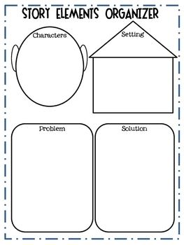

Theme: What can we learn from this story?

**The Kite Contest**