Night Final Project – Project with pairs

Project 1 – Thematic Journey with Selected Quotes
Guidelines and expectations:
- Create a THEMATIC “journey” to take us through the physical and emotional struggles of Elie during the Holocaust. You will need to use a variety of visual symbols– pictures - and quotes – that go along with your chosen theme(s).
- Each stop (listed below) must include quotes (8 total) of IMPORTANT events that go along with a theme.
- Each stop (listed below) must include written rationale of WHY this event is pivotal in the novel and to the theme and WHY the picture was chosen. If the quote does not easily point to an IMPORTANT event, it will be incorrect.
- Each stop (listed below) must include a picture that relates to the event/quote. The pictures can be symbolic or literal. If you found a picture and printed it online, it must have a link to where the picture was found – usually this is done under the picture. Be aware - if you just have a picture of the entrance to Birkenau for a quote that is about the separation of Elie and his family, it will be incorrect. The picture and the quote and the theme should match in tone and subject.
- You must include and label the following locations (in this order) to create a chronological guide to follow:
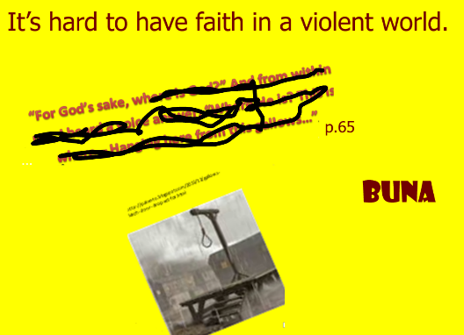
- Sighet 3-11 DO NOT USE THIS EXAMPLE
- Ghetto 11-22
- Train ride 23-28
- Birkenau 29-39
- Auscwitz 41-45
- Buna 47-83
- March to Gleiwitz/ Train to Buchenwald 85-103
- Buchenwald/liberation 103 - end
- The format of the final product is a PowerPoint or Sway or Book or similar
- Sources: If you gather information as you research and “borrow” images – provide a separate sheet with the web addresses or put the web address under the picture as shown above. If you use a separate sheet, label the pictures with numbers that correspond to the web address. This is an informal way of citing where you found your pictures.

*Visual representation – you need to find a variety find symbols, pictures, drawings, items, and images to represent the literal and figurative aspects of Elie’s physical and emotional journey through the Holocaust. Refer to the chapter questions to help guide you through each location.
**Textual support - Quotes work great to help relay feelings and thoughts (use quotation marks). Use words from the book, such as descriptions and quotes, to represent the struggle at each location. You may NOT use your own words.

**Rationale – Use your own words to describe why this quote is related to the theme, why it’s important, and why the picture or symbol or drawing was chosen.

Themes to consider –wording can be changed & you can create your own:
- There is a struggle to have faith in a violent world
- Humans are more likely to be silent and obey than fight or recognize problems
- It’s easier to be cruel to different looking/acting people who are slowly beaten down by oppressors
- There can be good reasons for not fighting back
- Cruel treatment could make good people mean

