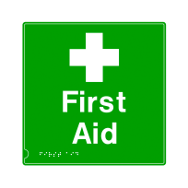Safety Handbook/Brochure Project
Safety is our number one priority in the lab. Everyone must follow these rules/expectations to keep safe while working. You will be designing a safety handbook/brochure to be available in our classroom. The handbook will need to have a title and a safety symbol on the front of the brochure. You will then need to create a second, third, and back page that explain 3 out of the 9 rules. Each page should explain the rule and have a picture. The handbook/brochure needs to be eye catching with good graphics and color. You will receive a daily grade that assesses whether you were on task while completing the assignment in class and prepared with your flash drive/materials. The total project will be out of 30 points.

Safety Handbook/Brochure Project
Safety is our number one priority in the lab. Everyone must follow these rules/expectations to keep safe while working. You will be designing a safety handbook/brochure to be available in our classroom. The handbook will need to have a title and a safety symbol on the front of the brochure. You will then need to create a second, third, and back page that explains 3 out of the 9 rules. Each page should explain the rule and have a picture. The handbook/brochure needs to be eye catching with good graphics and color. You will receive a daily grade that assesses whether you were on task while completing the assignment in class and prepared with your flash drive/materials. The total project will be out of 30 points.

