Dear Families,
Here is an update from the world of Math in Mrs. Doornbos’ room. Last year the class developed their skills in hanging fractions into decimals. So during the next segment of math class, we are going to be focusing on classifying numbers. This aligns with Common Core Standard Math. 8.N.S.A.1.
Students will start by create a foldable diagram to help them visually see where each number falls in this classification system. From there we will practice the new skill with card sorts and varying activities. Once students have mastered the skills they will complete a personal reflection chart, and they will ask you to sign off on their chart. Feel free to give them a problem so they can show their learning!
Please contact me with any thought questions, or concerns,
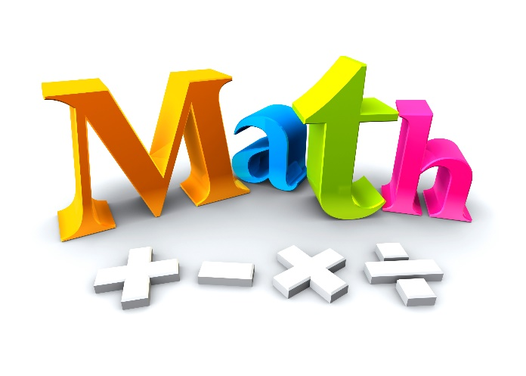
Karen Doornbos

I can statement. | Check off when mastered | Example
I can classify numbers as real numbers.
I can classify numbers as irrational numbers.
I can classify numbers as rational numbers.
I can classify numbers as integers.
I can classify numbers as whole numbers.
I can classify numbers as natural numbers.
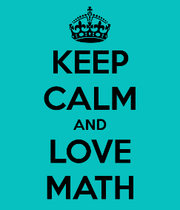
I can monitor my learning

