Charles Demuth
“5” Inspired Typography

Project Objective: Create an original design using each of the 4 types of lettering styles (roman, poster, script & unusual-in Serif & non-serif font types) in a visually interesting composition. Create a focal point using size variation and color contrast. Vary the size and angle of the letters or numbers. Use black and white design in the background.

Materials: 12×18” paper, rulers, examples of font alphabets, colored pencils, sharpies (markers optional)

Sketch Instructions:
- Choose 5-7 Letters, Numbers & Characters to draw.
- Create AT LEAST 2 thumbnail sketches on the DESIGN TEMPLATE to work out your composition. Choose one letter to be your focal point (area of emphasis) through style, size, color and contrast.
- You must use each 4 styles of lettering for a different letter or number (there will be 1+ repeated styles depending on how many letters you put in your design).
- Tips for design:
  - Vary the sizes and angles of the letters/numbers.
  - Overlap some of the letters/numbers.
  - Have some designs go off the page.

Computer Instructions:
1.Create the Design on the computer using Word:
  - Use Microsoft Word to create your basic composition.
    - Open a new document.
    - Insert a rectangle onto the page. Change measurements to 6 inches tall and 4 inches wide.
    - Insert “word art”-the outline only style- individually of 5-7 Letters, Numbers & Characters. Place these letters and numbers inside the rectangle.
    - Overlap, twist (rotate), and have the letters go partially off the page to make the composition more interesting.
    - Save the document to your flashdrive.
    - Print.

Drawing/Shading Instructions:

- On a 12×18” sheet of white paper, in pencil draw a 3” square grid.
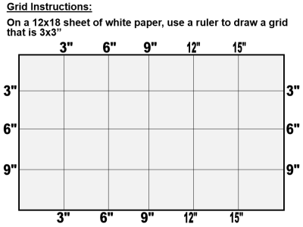

- Draw your design in pencil.
- LETTERS, Numbers & Characters: will be rendered in color. Use colored pencils/markers for the letters/numbers. Make sure you choose your focal point to be in color and balance the other colors throughout the piece.
- BACKGROUND: background will be in black & white-create a positive & negative space reversal patterns in your art. Use Sharpies for the background. Create various patterns in the background to change the values.

Handout designed for lesson from https://createartwithme.com/font-styles-lettering-design-mixed-media-lesson/

s
My Example
4

Fonts used:

Roman Style: Thick and thin
- Sitka Small-4

Poster style: Bold
- Berlin Sans FB-C
- Bahnschrift SemiLight-S
- Gadugi-1

Script Style: Looks like handwriting (cursive)
- Gigi-S

Unusual or trademark: Unique and creative
- Curlz MT-&
- Algerian-3

1
S
&
C

3

