**Name**: ______________________________

**____________ Copy**

**Test: November 10, 2017**

**Skill: spelling/reading pattern (ar)** *Grade 3*

This letter pattern is known as “**bossy r**”

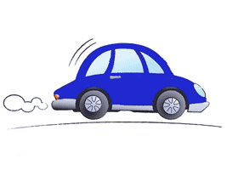1. car   
2. farm  
3. dark  
4. art

I can C:\Users\JEANOLD\AppData\Local\Microsoft\Windows\Temporary Internet Files\Content.IE5\4GUUZFA9\MC900437990[1].wmf C:\Users\JEANOLD\AppData\Local\Microsoft\Windows\Temporary Internet Files\Content.IE5\JH4IJ53I\MC900440428[1].wmf

1. **read** the words. ____
2. **spell** words with the “r” sound. ____
3. **write sentences** correctly when dictated to me. _____

5. start

6. chart

7. smart

8. card

**Sentences:**

1. When did they start to march at the dark farm? (12)
2. My card had a shark and a car on it. (12)

9. hard

10. march

11. shark

12. sharp

13. harm

14. mark

15. target

16. carpet

*** garden *\*\*\*challenge words are to be practiced but will not affect*

*** large your *grade if spelled incorrectly.*