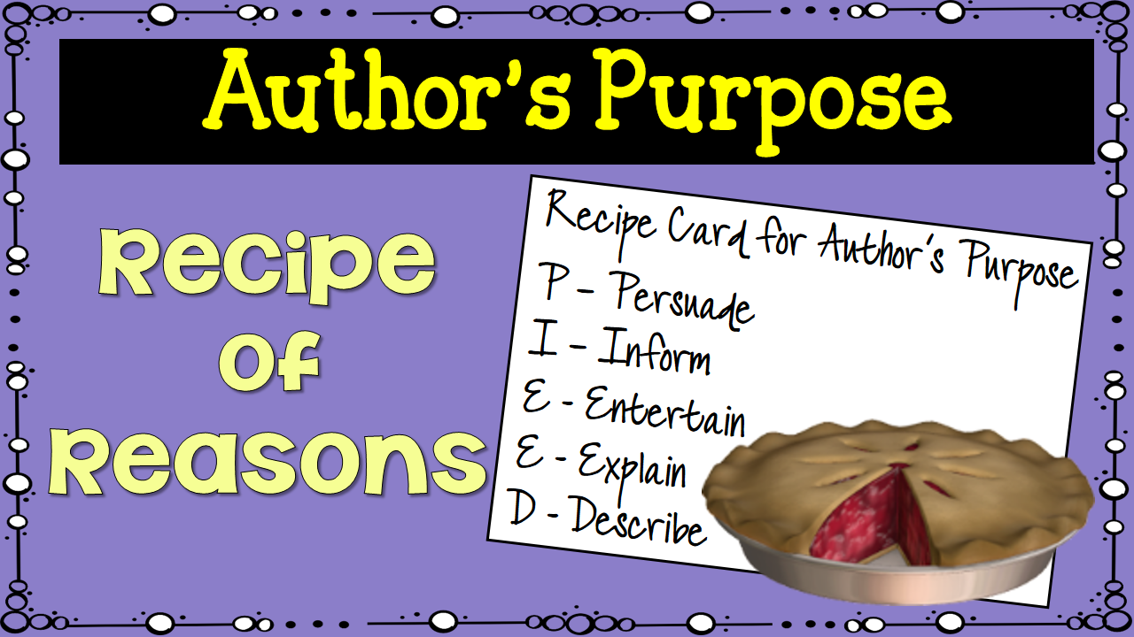

This week we are learning to identify an author’s purpose. These activities will help you practice what you have learned.

CENTER 1 - GAME UP!
Play these games with your group to practice identifying the author’s purpose

Recess Room – Play this Recess Room game with a partner from your group or on your own. You can play the game as many times as you want to improve your skill. See who is the overall winner of your small group by playing tournament style with winners playing winners and losers playing against each other. http://www.roomrecess.com/mobile/AuthorsPurpose/play.html

Author’s Purpose Jeopardy – Divide your group into two teams to play this game. Your group leader will be your score keeper. See which team gets the highest score.

https://jeopardylabs.com/play/authors-purpose6

CENTER 2 – BrainPop!
Watch the Purpose for writing video and take the quiz. Then use your interactive notebook and practice writing for different purposes.

https://www.brainpop.com/english/writing/typesofwriting/?

Center 3 – Get PIE’ED CRAFTY
Play Get PIE’ED Concentration with your group. Then work together as a group to create the Author’s Purpose pie.

Center 4 - Leveled Reader Activity
Read the leveled reader assigned to your group and complete the detail chart to determine the author’s purpose. Discuss your reader as a group, compare your details, and see if you all agree on the author’s purpose.

Center 5 – Supporting Details
Work with Mrs. Maranto to learn how to use supporting details to help you identify the author’s purpose.

Center 6 – Task Cards & Test Prep
Work with your group to sort the task cards according to the author’s purpose. Create an Author’s Purpose chart that shows the author’s purpose.

