ATTRACTING WILDLIFE LANDSCAPING PLAN 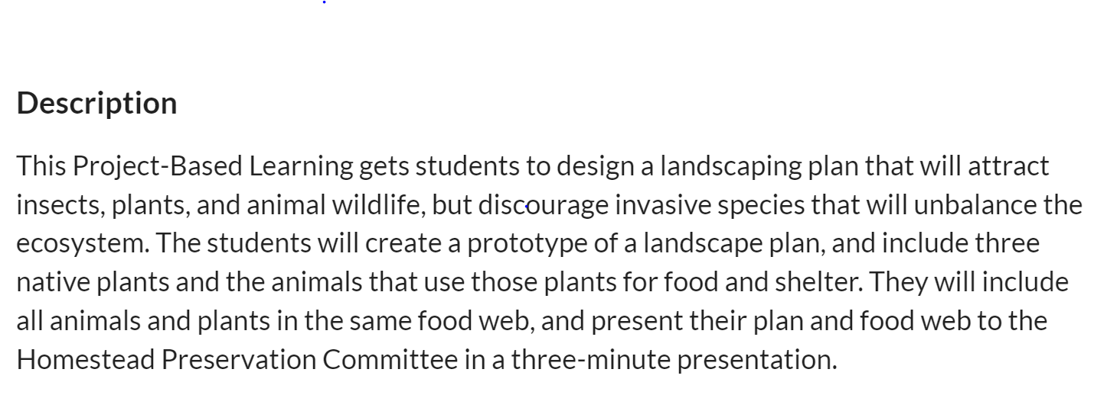 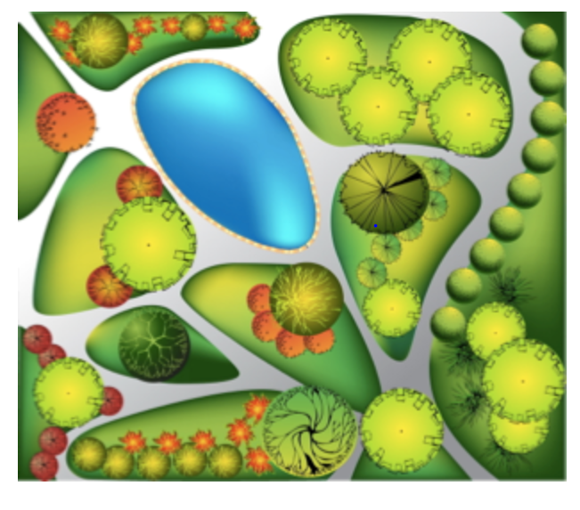

The Links on This Page Will Help Your Group Complete This Task

Gaming Links – All Group Members Should Play These Games to Learn About Food Chains.

Kid’s Corner Food Chain Game
http://www.sheppardsoftware.com/content/animals/kidscorner/games/foodchaingame.htm

Build-A-Food-Chain Game
http://www.cserc.org/sierra-fun/games/build-food-chain/

Brain Pop Food Chain Game
https://www.brainpop.com/games/foodchaingame/

Brain Pop Food Chain Video
https://www.youtube.com/watch?v=33pC31rw9bM

Landscape Design Engineer Project Resources
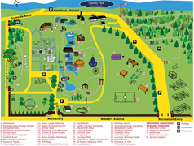

http://www.mokenapark.com/parks-and-facilities/parks/yunker-park-site/

http://www.mobilemaplets.com/showplace/6218

Zoologist Project Resources
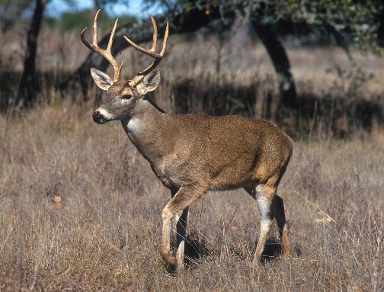
http://www.museum.state.il.us/exhibits/agriculture/htmls/plants/wild_plants/plants_wild.html

Animals native to illinios

https://en.wikipedia.org/wiki/Fauna_of_Illinois

https://www.huffingtonpost.com/reboot-illinois/9-illinois-critters-that_b_7787342.html

Botanist Project Resources
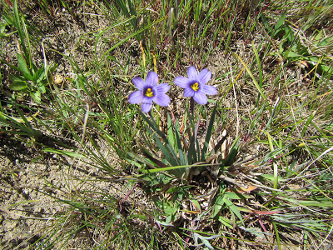

http://www.museum.state.il.us/exhibits/agriculture/htmls/plants/wild_plants/plants_wild.html

https://www.dnr.illinois.gov/publications/Documents/00000679.pdf

http://extension.illinois.edu/wildflowers/nativeplants.cfm

