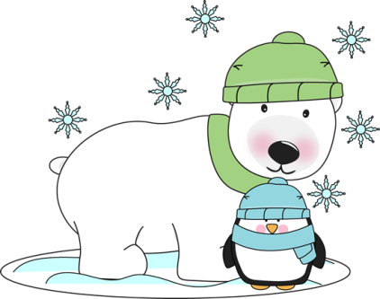 **January**

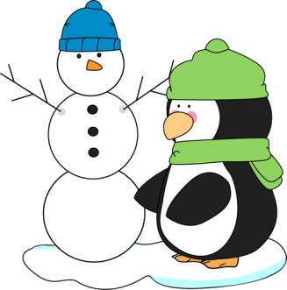

IMPORTANT DATES/REMINDERS:

* Please encourage hand washing, as spreading illness is still a concern during this time of year.
* Please look at this week’s homework schedule, as it has changed. I have explained to the class that we are getting closer to third grade so work and responsibility will be increasing to prepare. 😊

Weekly Theme: Winter Animals

Our class will be reading the Mitten and weekly stories will be related to the story The Mitten OR Artic Animals.

Phonics: We will continue to focus on glued sounds with the /old/ sound

Math

Focus is on 3.4- adding three numbers together and fact families (number bonds)

Spelling Words: /old/ words

1. old 9. scold

2. cold 10. gold

3. fold

4. hold bonus

5. bold artic

6. sold mitten

7. mold

8. told

1. b band
2. hand
3. land
4. sand
5. think
6. sink
7. pink
8. wink
9. link
10. rink

BONUS words

1. blink
2. bland
3. and
4. hand
5. land
6. sand
7. think
8. sink
9. pink
10. wink
11. link
12. rink

BONUS words

1. blink
2. bland

Mrs. Carda’s Weekly Newsletter

Week of January 22nd