Save the Date

- Friday, August 18th – Orientation & School Supply Drop-Off
- Wednesday, August 23rd – First Full Day of School for Students
- Tuesday, August 29th – School Picture Day
- Thursday, September 7th Curriculum Night 6:30-7:45
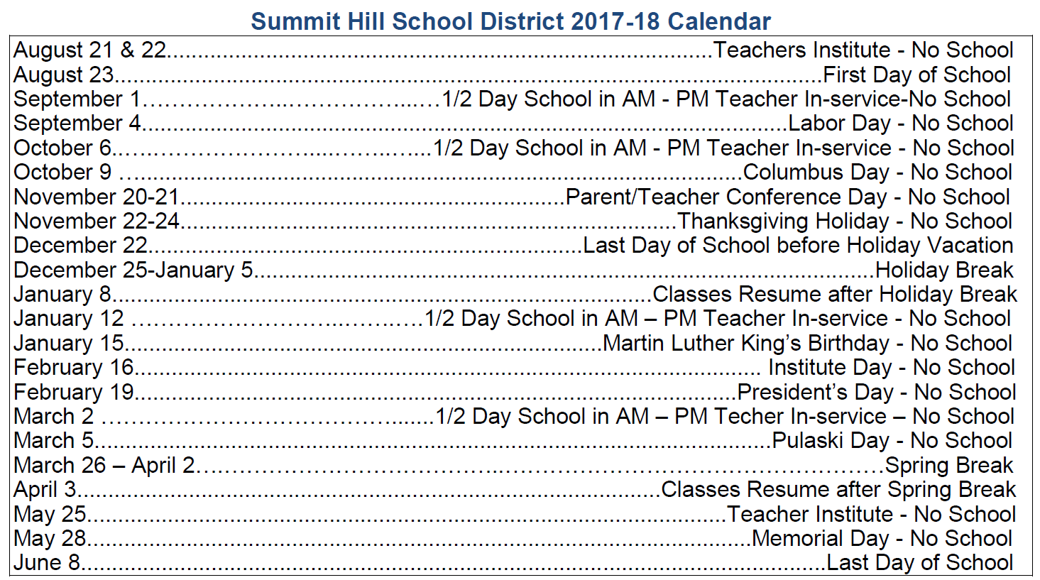
Arbury Hills School
School Supply List
2017-2018
Grades 1-4
SUPPLIES NEEDED | GRADE | GRADE | GRADE | GRADE
 | 1 | 2 | 3 | 4
Calculator | 0 | 0 | 1 | 1
Construction paper multi-color (9x12) | 1 Pkg. | 0 | 1 Pkg. | 1 Pkg.
Colored Pencils | 0 | 0 | 1 box | 1 box
Crayons (maximum 24) | 4 boxes | 2 boxes | 1 box | 1 box
Dry Erase Markers (low odor) | 4 | 4 | 4 | 4
Dry Erase Eraser | 1 | 1 | 1 | 1
Eraser Mate pens (blue or black) | 0 | 0 | 0 | 2
Erasers (Pink, not pencil top) | 2 | 2 | 1 | 2
Glue bottles (no colors) Elmer’s | 2 (8 oz.) | 1 (4 oz.) | 1 (4 oz.) | 1 (8 oz.)
Glue sticks | 10 | 6 | 4 | 2
Hand Sanitizer (16oz) | 1 | 1 | 1 | 1
Headphones | 1 | 1 | 1 | 1
Highlighters | 1 | 2 | 4 (diff.colors) | 4 (diff.colors)
Index cards size 3x5 | 300 | 200 | 200 | 200
Kleenex (shared with specials) | 3 boxes | 3 boxes | 3 boxes | 3 boxes
Loose leaf paper (not college rule) | 0 | 0 | 2 Pkgs. | 2 Pkgs.
Markers (washable broad tip)  ** 1st & 2nd grade only wants "classic" colors of markers | **1 set  classic colors | **1 set  classic colors | 1 set | 1 set
Paper Towels | 2 rolls | 2 rolls | 2 rolls | 2 rolls
Pencils No. 2 (24) (sharpened) | 2 Pkgs. | 2 Pkgs. | 2 Pkgs. | 2 Pkgs.
Pencil Case | 1 | 1 | 1 | 1
2-pocket folders (solid colors only) | 5 | 5 | 5 | 5
Protractor (clear) | 0 | 0 | 0 | 1
Red Pens | 0 | 0 | 2 | 2
Ruler (inches and centimeters) | 1 | 1 | 1 | 1
Scissors (pointed Fiskars) | 1 pair | 1 pair | 1 pair | 1 pair
Spiral notebooks (single-subject not college rule) | 0 | 2 | 3 | 3
Scotch Tape | 1 | 1 | 1 | 1
USB Thumb/flash drive with a minimum of 2GB | 0 | 1 | 1 | 1
Wet wipes (antibacterial / unscented / shared with specials) | 3 containers | 3 containers | 3 containers | 3 containers
Ziploc bags – Gallon size | 1 box | 1 box | 1 box | 1 box
Ziploc bags – Quart size | 1 box | 1 box | 1 box | 1 box

PLEASE NOTE:
- Book Bag & Gym shoes with laces and/or Velcro are required for grades 1, 2, 3, & 4. Gym shoes may not have black soles.
- Please label ALL supplies with first and last name. All individual crayons and markers need to be labeled.
- Some supplies may need to be replenished during the school year.
- No Trapper Keepers

